Manuscript #: JAP24-AR-00699R

**Reviewer #1 (REMARKS to AUTHOR(s)):**  
  
*The author proposed a 2D kinetic Ising model (IM) to simulate Arctic sea ice dynamics on a large length scale. The IM is an idealized model in statistical mechanics, and the author modified this model by introducing continuous spin values between -1 and 1 to describe the mixture between ice and water. The classical Metropolis-Hastings algorithm is used for time evolution, and the author modified this algorithm by introducing a factor to account for the inertia of spin value changes. The parameters of the IM are estimated based on observations, and many observed features are well captured by the IM.  
  
This paper applies statistical physics to an important problem in climate science, so it should be of great interest to both communities. Therefore, I can recommend the publication of this paper after the following minor issues are addressed.*  
  
Abstract:  
  
1. The length scale being modeled in this paper should be clearly stated. Arctic sea ice has multiple length scales, and it should be stressed that this paper focuses on a large scale.

EW: We have stated the scale in the abstract as your suggestion

2. It should be clarified that the continuous spin values are between -1 and 1. By default, a continuous variable can take values between -infinity and infinity, which is unphysical.

EW: We have clarified on the bounds of the spin value in the abstract as suggested.

Section V.A:  
  
1. In Table 1, the last row should be I instead of J. The fluctuations of the parameters I, J and B_0 are quite regular and well explained, but the fluctuations of the parameters B_x and B_y are much wilder and not explained. If unexplained, these fluctuations may imply overfitting. A related question is whether the estimated parameters are consistent across multiple runs of the dual annealing optimization method, especially for B_x and B_y. If not, then the probability density functions of the estimated parameters should be provided.

EW: We have corrected the last row of table 1 to be *I*. Thanks a lot for catching this typo.

The fluctuations of the parameters Bx and By can be explained by the geographic distributions of ice over time. We have added explanations to the paper on page 10, with more details included here.

The focus area we pick is illustrated in Figure 1 of the paper, which is copied below for your convenience of reading. $B_{0}$ is B at the center of the lattice with coordinates $x_{0}$ and $y_{0}$. Coordinate x corresponds to the row of a lattice, going incrementally from top (when it is negative) to bottom (when it turns positive); y coordinates correspond to the columns of the lattice going incrementally from left (when negative) to right (when positive).

Interestingly, the area marked by a red oval in Figure 1, the so-called Canadian Arctic Archipelago, has much thicker ice than elsewhere including the north pole region (the gray circular mask). In fact, many scientists believe this region will be the last piece of ice standing in the Arctic when the Blue Ocean Event happens. As the bottom of the focus area is usually covered by more ice, Bx is mostly negative, except for very few periods (E.g. 11/1/2022->11/16/2022, 9/16/2023->10/1/2023) when the ice coverage remains relatively unchanged.

Similarly, y coordinates increase in the direction toward the north pole. It is interesting to see that the impact of y direction is slightly less pronounced than that of x. It is consistent again with the finding that the ice in Archipelago is thicker than that at the north pole, which mitigates the impact of y coordinate.

In summary, the value of Bx and By depends much more on the idiosyncratic geographic distribution of ice across neighboring periods, so the fluctuations of Bx and By are much wider than *J, I, B0* as you pointed out. They are consistent across multiple runs of dual annealing. This finding does show that our simplified linear functional form of *Bi = $B_{0}+B_{x}\left(x_{i}-x_{0}\right)+B_{y}(y_{i}-y_{0})$*  can be further improved to model the full effect of external field; it can be enriched by linking to actual geographical and environmental factors to enhance the power of the Ising model in future research.

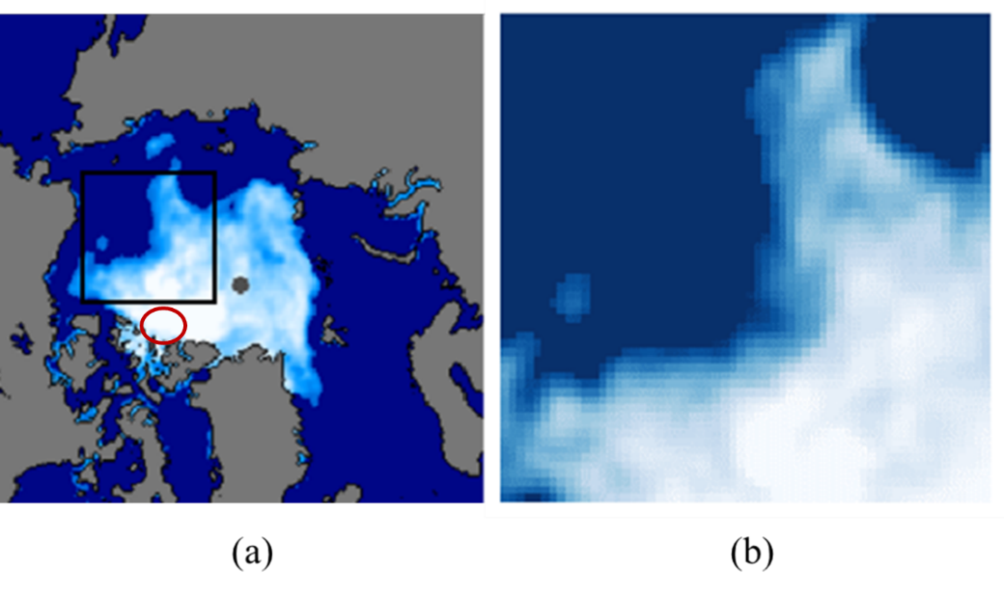

2. It would be useful to discuss the critical temperature for this version of the IM and whether the estimated IM temperature is below or above this critical temperature. This will provide valuable insights into the role of environmental noise on the time evolution of Arctic sea ice.

EW: We agree that critical IM temperature will provide valuable insights on the environmental noise to the sea ice evolution. Based on our current study, we are not equipped to answer whether the estimated IM temperature is below or above the critical temperature. The critical temperature is out of scope for this research paper which focuses on kinetic non-equilibrium evolution only. However, critical temperature and phase diagrams of a 2D Ising lattice with continuous spin value are very interesting from both theoretical and computational perspectives. Some studies have found richer phase diagrams and second order phase transitions for certain types of continuous spin IM, including ref [36] by Bayong E. and Diep, H.T. and [41] by Krasnytska, M. et al. We can explore along this direction in future related research.

Manuscript #: JAP24-AR-00699R

**Reviewer #2:**

General Comments

This paper deals with the Ising model with continuous-valued spin configuration for modeling the Arctic sea-ice concentration field. A Monte-Carlo-based optimization technique is used to find optimal parameters to match the final concentration data. The objective function employs an ’inertia’ factor, punishing drastic changes between subsequent configurations in the dynamics.

The paper demonstrates the applicability of the Ising model to sea-ice dynamics, which is interesting

and promising. Once fitted against the initial and final configuration, the model shows excellent agreement between the simulation and actual data for the intermediate time steps. While the paper is generally well written, the tone is often expository and will benefit from making some statements more technical to appeal to the target audience. Some statements are missing relevant citations.

Overall, this is an interesting paper and deserves publication in Journal of Applied Physics after quite a bit of revision and attending to the points below. The idea to use a continuous spin Ising model to describe the values of the sea ice concentration field which takes values between 0 and 1, rather than a binary model, is novel and powerful. The introduction needs to be augmented to better describe up front what is assumed, what is fit, and so on, in other words, what are the inputs and outputs of the model. What would happen if you started with known initial conditions from sea ice data, and then explored different scenarios of evolution for different parameter regimes, regardless of what the actual evolution looked like?

EW: We have replaced the original introductory paragraph with a research outline, which includes the research goal, the physics model, assumptions, methodology, inputs, and outputs.

Regarding the known initial conditions and evolutions in different parameter regimes, it is probably better to discuss after the description of the Ising model and Monte Carlo procedures. Therefore, we have added a paragraph at the beginning of section IV.E for this discussion.

Specific Comments

1. The first sentence of the paper, “The rapid loss of the Arctic sea ice over the past four decades has been an alarming phenomenon that points to drastic global warming, a serious challenge that calls for collective actions by the entire humankind,” and much of the Introduction, is inappropriate for a publication in a professional physics journal.

EW: We have replaced this paragraph with the research outline.

2. On page 3, “... the feedback loop effect may occur, i.e., less reflection and more absorption of solar energy, leading to even more ice loss and further global warming.” It should be stated that this is usually called “ice-albedo feedback.”

EW: We have revised as suggested

3. Eq 1: It is unclear why the interaction *Jij* cannot be negative (i.e., antiferromagnetic)? Is is enforced in the method, or does it just come out of the optimization process?

EW: We agree that *Jij* is negative for antiferromagnet materials. For the research in this paper, it is naturally the case that the areas surrounding ice will be more likely to freeze, and those surrounding water will tend to melt. Therefore, *Jij* is expected to be positive given such intuition. In fact, it is confirmed in our study by the results coming out of the optimization process instead of being enforced, matching our intuition. We have revised the paper accordingly on page 3 and also for explanations of table 1 on page 10.

4. Allowing $σ_{i}=0$ in the model introduces the possibility of ‘noninteraction’ (coinciding with *Jij=0* ) with any lattice site with 50% ice. Although it is numerically unlikely for any lattice site to achieve zero value exactly, theoretically, it is not ruled out. This poses a theoretical challenge which should be addressed.

EW: $σ_{i}=0$ is possible, though numerically extremely unlikely. This could be a challenge for the original binary Ising model, but in the context of this paper, it has a natural physical explanation of a cell comprising exactly 50% water and 50% ice. In this case, the impacts from water and ice to an adjacent cell offset each other, making the net effect neutral. Therefore, this *σi* = 0 case imposes no issue for the study in this paper.

5. P4 l10: Is the energy same as the Hamiltonian H in Eq 1? Or is it the argument of the exponential in Eq (5)? Please clarify.

EW: The Hamiltonian *H* in Eq (5) is the same as Eq (1) in section II.A. The total energy required for a spin flip is $∆E=H_{ν}-H_{μ}+I{{|σ}^{'}}_{i}-σ_{i}|$, which consists of two parts: the system Hamiltonian change plus the inertia effect. We have added more clarification to the paper on page 5.

6. P6: The methodology will benefit from a little more explanation. It is not clear in what order the simulation and the optimization are carried out. I propose adding a subsection to the beginning of Section IV to outline the methodology and how Subsections IV.A - IV.E are tied together.

EW: We have added a paragraph at the beginning of section IV on page 6 to outline the methodology.

7. Error analysis: An error plot showing the simulated and actual data would help demonstrate the results better. Section IV.E mentions l1-based optimization, but how small is the tolerance? The author provides the comparison of some useful statistics such as extent and coverage. In addition to the visual similarities (in the ‘eyeball norm’) described in the figures 3, 4, 6, and 7, a pointwise (or lp) error plot would be useful to demonstrate the difference.

EW: Thanks for the advice. We have added a heatmap as figure 5 in the updated paper manuscript to show the absolute difference in the ice coverages between figure 3 and 4. This figure is also copied below as Figure I for your convenience of reading. The heatmaps are very revealing: the small red patches associated with poor match mostly appear around the boundaries between water and ice, implying that the majority of the discrepancy between the simulated and actual images happens around these border areas. This result is not surprising: the IM apparently does not perfectly model all these boundary granularities, while doing a good job at capturing the overall patterns.

Figure I: (a) - (n) are heatmaps illustrating the absolute difference (between 0 and 1) in the ice coverages between Figure 3 and Figure 4 for each semi-monthly period, from (a) June. 16th, 2022 to (n) Jan. 1st, 2023. Yellow color indicates a good match and red a large difference, as shown by the color scale on the right

Similarly, we calculated the difference on the daily sea ice evolutions between Figure 7 and 8 in the paper, with the corresponding heatmaps shown in Figure II below, and the difference between Figure 9 and 10 with results shown in Figure III.

Again, the majority of the discrepancy happens around the border between water and ice, but the IM preserves the overall ice/water dynamics on the daily time scale.

Due to the length constraint of the paper, Figure II and III are not included in the paper.

Figure II: Heatmaps illustrating the absolute difference in the daily ice coverage between Figure 7 and 8 of the paper, from (a) Aug. 16th, 2022 to (q) Sept. 1st, 2022.

Figure III: Heatmaps illustrating the absolute difference in the daily ice coverage between Figure 9 and 10 of the paper, from (a) Oct. 16th, 2022 to (q) Nov. 1st, 2022.

8. Extrapolation: Can the author comment on the extrapolation abilities of the model? For example, once the best-fit parameters are obtained for 2022, to what extent can it be recycled for 2023 or 2021?

EW: Thank you for this great question. If we recycle the full-year best-fit parameters from one year to another, the results are not expected to match the observed configuration very well. As we start our simulations in June with a lattice almost fully covered in ice and end in Dec in each year, the idiosyncratic intra-year configurations will be very hard to be reproduced by the Ising parameters in another different year.

However, in August 2023 right after the hottest July, we did test the projection of Sept 2023 to Jan 2024 based on the 2022 best-fit parameters as an experiment. Specifically, we use the following parameters in Table I below, which is the same partial data from Aug. 16, 2022 onwards in Table 1 of the paper.

|  |  |  |  |  |  |  |  |  |  |
| --- | --- | --- | --- | --- | --- | --- | --- | --- | --- |
|  | **8/16 to 9/1** | **9/1 to 9/16** | **9/16 to 10/1** | **10/1 to 10/16** | **10/16 to 11/1** | **11/1 to 11/16** | **11/16 to 12/1** | **12/1 to 12/16** | **12/16 to 1/1/2023** |
| *J* | 2.7 | 2.3 | 2.6 | 2.7 | 2.6 | 2.5 | 2.3 | 2.7 | 2.7 |
| *B0* | 4.3 | 3.6 | -12.6 | -12.7 | -14.9 | -9.6 | -15.0 | -13.1 | -14.4 |
| *Bx* | -7.5 | -8.2 | -10.0 | -6.1 | -8.5 | 9.7 | -1.9 | -0.8 | -3.1 |
| *By* | -6.4 | 2.9 | 0.1 | -8.4 | -5.6 | -10.0 | -5.9 | 5.4 | -8.0 |
| *I* | 10.7 | 10.9 | 10.6 | 9.3 | 9.4 | 10.4 | 9.1 | 10.9 | 10.8 |

Table I: The best-fit Ising parameters from Aug 16, 2022 to Jan 1, 2023 sea ice evolution.

We start with the actual configuration of the focus area as of Aug 16th, 2023, and then run the simulation process for 9 periods forward till Jan 1st, 2024 using the above parameters to predict how 2023 evolves. The predicted images are shown as (b) Sept 1st, 2023 to (j) Jan 1st, 2024 in Figure IV, in comparison to the actual observations in these periods shown in Figure V (b)-(j). It can be seen that the first 2 periods in (b) & (c) match pretty well, but later periods from (d)-(f) show more visible divergence, missing certain localized configurations. Nevertheless, the predictions display similar overall trend as the observations.

Figure IV: The simulated semi-monthly evolution of sea ice in our focus area in the near future. (a) is the actual image on Aug 16th, 2023 as the start state; (b)-(j) are simulated images (based on the best-fit IM parameters in the 2022 simulations over the corresponding semi-monthly periods) from (b) Sept 1st, 2023 to (j) Jan 1st, 2024.

Figure V: The actual semi-monthly evolution of sea ice from (a) Aug 16th, 2023 to (j) Jan 1st, 2024

Moreover, we checked the ice coverage percentage and the ice extent based on the above predictions. In Figure VI, the blue curves are actual 2023 observations; the orange curves from Jun 16th to Aug 16th, 2023 are based on 2023 best-fit Ising parameters, while from Sept 1st, 2023 to Jan 1st, 2024 they are based on 2022 best fit parameters and the results in above Figure IV and V.

Figure VI: (a) The ice coverage percentage and (b) the sea ice extent for our focus area in 2023. The predicted (orange) curves from Sept 1st, 2023 onwards are based on 2022 best-fit parameters.

Notably, although larger deviations are observed from Sept 1st and later in Figure VI(b), our experiment accurately predicted the ice extent in Sept 2023 to be the second lowest in history for this focus area. This shows that, the extrapolation ability of our model, even though far from being perfect, is strong and can offer many insights into the sea ice dynamics for the near future.

Due to length constraint of the paper, the above details this analysis is not included in paper. However, it is briefly discussed in Section VI.A.

9. A methodological concern: the paper could use a comparison with a simpler model (say, “vanilla Ising”) in order to make the present results compelling. i.e., given a four parameter simplification of this model, are the fits just as good, or only slightly worse? If so, then the conclusion isn’t that the inertia term is needed— it’s that the standard Ising model (as-is) can already describe seasonal variation in sea ice extent. That would also be an interesting result, but it would be fundamentally different from the central claim of this paper, which is that the inertia term is important. It may well be, but it’s not yet compellingly argued. Comparison is necessary to show improvement.

EW: We have explored the vanilla Ising model without the inertia factor at the earlier stage of this research. The performance of the simulation for 2022 using vanilla Ising are shown in Figure VII (the simulated semi-monthly ice), VIII (differential from the actual as heatmaps), and IX (ice coverage percentage and ice extent), respectively.

In Figure VII, the simulated semi-monthly sea ice configurations show a much larger discrepancy from Figure 3 and 4 in the paper even by eyeballing. Figure VIII shows the numeric differentials in heatmap, confirming the same observation as Figure VI. Figure IX shows the two numerical measures for similarity, which again shows worse performance compared to Figure 6 in the paper, where the inertia factor is taken into account.

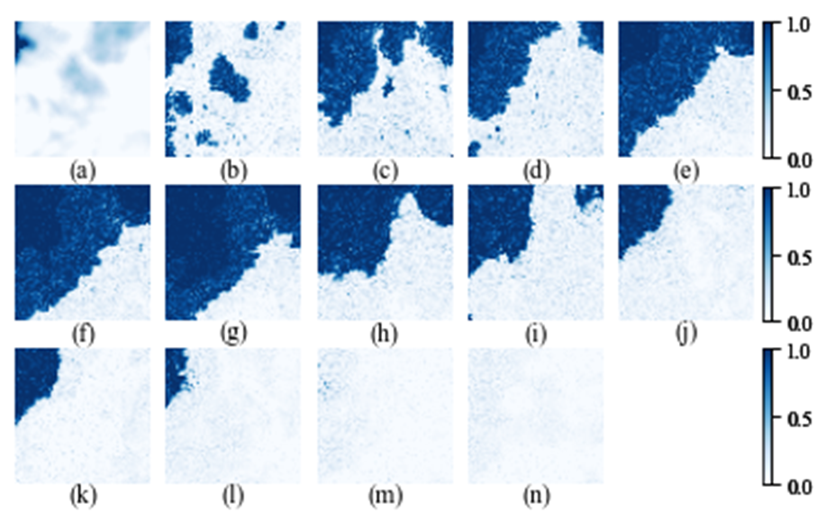

Figure VII: The simulated semi-monthly evolution of sea ice for our focus area in 2022, using the Ising model without the inertia factor

Figure VIII: Heatmaps illustrating the difference in the ice coverage between Figure 3 in the paper and the above Figure VI using the Ising model without the inertia factor

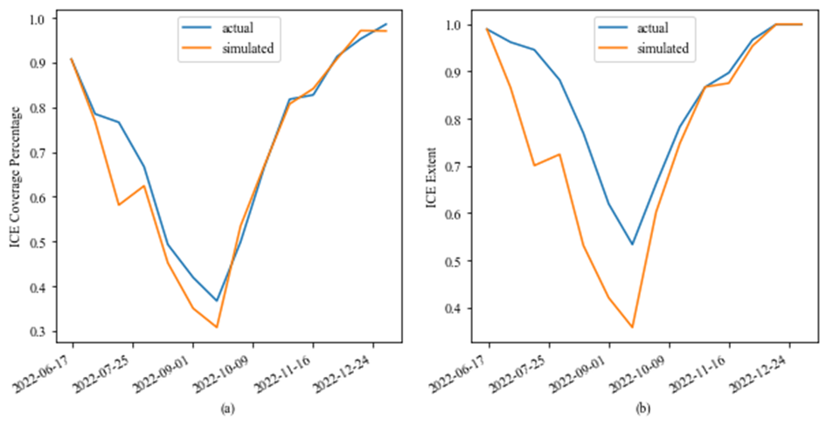

Figure IX: The ice coverage percentage and the ice extent of 2022, where the simulated curves are based on the Ising model without the inertia term

In conclusion, we see that adding the inertia factor makes the simulation process much more robust, validating that this added feature has significant strength in sea ice modeling. Intuitively, this finding indicates that Arctic sea ice and water have a tendency to stay unchanged even in the presence of external forces. That said, we will not claim that this inertia factor is a must-have. It might be possible to improve the Ising model performance via other novelty than the inertia factor, e.g. enriching the functional forms of *J* and *B*, which is out of scope of this paper yet can definitely be explored in future research.

Due to length constraint of the paper, the above details this analysis is not included in paper. However, it is briefly discussed in Section VI.A.

10. “Use of language” concerns: quite a few instances of opinion and emotional language in the text.

EW: We have had thorough revisions wherever we see fit.

11. Lack of citations for “obvious” claims.

EW: We believe this question refers to section IV.D. We have reworded with more explanation, and added a reference [22] to Stepinski, T.F. et al in section IV.D of the paper..

12. The form of the inertia term is a little unmotivated— why this and not something else?

EW: We have added more explanation to section II.C of the paper. An analog of the inertia factor is the latent heat of water/ice phase transition, which motivated us to propose this inertia factor to have the dimension of energy. In physics, the total energy change for water/ice phase transition at constant temperature and pressure is proportional to the mass, therefore the simplest and also most sensible assumption is to have our inertia term as $I{{|σ}^{'}}_{i}-σ_{i}|$, which means that the required additional energy is proportional to ice coverage change. Therefore, we started with the simplest linear form; it turns out that this IM works pretty well. Nevertheless, it is possible to have other functional forms for the inertia factor, which is out of scope for this paper.

13. Its acknowledged in the paper that a different repetition number could have led to different parameter fits; this is potentially problematic, as it introduces an “almost” degree of freedom.

EW: It is common to pick reasonable repetition number for kinetic Ising model simulation. For example, in section 2.1 of reference [22] by Stepinski T.F. et al, it states that “To ensure that the number of dynamic steps taken is proportional to (Δt)i, it is necessary to establish a unit of time that corresponds to the duration of a dynamic step. … A different time unit can be either larger or smaller than 0.876 h, but it must remain consistent throughout the simulation to ensure that the number of steps for each transition is proportional to its duration”. This does introduce a degree of freedom, but the method is not problematic, because we are not going to tie the absolute values of the best-fit Ising parameters to the exact physics quantities in the real world.

14. Issues of notational clarity in a few places; see below, but especially the $σ_{i}^{'}$ (which is actually misleading and not explained until much later in the text) and the use of the word “energy.” It also looks like more clarity is needed with regard to the normalization of the probability density. It may be normalized within the code, but as stated in the manuscript, it’s pretty clearly wrong.

EW: We have added description of $σ_{i}^{'}$ in section II.C, the first time it is introduced. Even though Hamiltonian and Energy are often used interchangeably in classical physics, we have clarified per your suggestion. In this paper, Hamiltonian refers to the energy state of the system; Energy change of the flipping process is Hamiltonian change plus the inertia term.

The probability density is normalized in the code as a standard process of the Metropolis Markov Chain Monte Carlo. For more details on this, please see the answer to question 23.

15. A few typos/grammatical issues; see below.

EW: Thanks for pointing out. We have revised per your comments.

16. “The fact that the year 2023 has witnessed the most sizzling summer on record and the hottest year in history adds even greater severity to such urgency.” Facts should be cited, and “sizzling summer”feels too informal here— great for an essay, less great for technical writing.

EW: We have reworded and added citation.

17. Ising model or Ising Model? Within the text I think it should be Ising model. Capitalization is a little inconsistent throughout the first couple of paragraphs before changing to just “IM.”

EW: “Ising model” is more commonly used. We have changed all cases to Ising model or IM.

18. “Onsager identified that there exists a critical temperature *Tc = 2.27 J/kB* when the phase transition happens in a 2-D IM. Later studies of IM in higher dimensions have been closely associated with various developments in advanced 20th-century physics and mathematical theories, including the transfer matrix method, quantum field theory, mean- field theory, etc.” I assume that the *2.27 J/KB* figure comes from either Figure 6 or Figure 7 of the Onsager paper cited, but I don’t see the number stated anywhere; is this the correct paper reference for this claim? It would also seem proper to cite the applications in transfer matrix method, etc.

EW: Onsager’s paper is the correct one. *2.27 J/kB*  comes from the first equation in the abstract of Onsager’s paper: $\sinh\left(\frac{2J}{k_{B}T_{c}}\right)\sinh\left(\frac{2J^{'}}{k_{B}T_{c}}\right)=1$, where J and J’ are interaction parameters for two different directions. For a uniform 2-D IM, setting J=J’ we have $\sinh^{2}\left(\frac{2J}{k_{B}T_{c}}\right)$ =1. After a few steps of algebra, it gives $T_{c}=\frac{2J}{k_{B}ln⁡(1+\sqrt{2})}≈2.27\frac{J}{k_{B}}$.

We have added citation for transfer matrix method, quantum field theory and mean-field theory in the paper.

19. “a major climate change indicator that is of significant environmental, economic, and social significance” Needs citations.

EW: We have added citation.

20. “Moreover, the Arctic ecosystem is directly impacted by the change in sea ice coverage, which, for instance, threatens the lives of polar bears and walruses who rely on sea ice for hunting and breeding.” Citations needed.

EW: We have added citation.

21. “*Jij* is usually positive, meaning that adjacent spins are inclined to maintain the same value to achieve low energy.” ...What does “usually” mean here?

EW: Similar as question #3. We have reworded and explained in the paper.

22. “The probability of each spin flip depends on whether such a flip increases or reduces energy” Energy has never been defined here; she’s almost certainly referring to the Hamiltonian, but it would be nice for that to be made explicit.

EW: We have reworded to Hamiltonian as your comments.

23. “mathematically the probability is determined by $e^{-β(H_{ν}-H_{μ})}$, where *Hv* and *Hµ* represent the Hamiltonian of the system before and after the flip. It can be easily seen that a higher IM temperature leads to more thermal fluctuations and greater randomness in the spin value distribution, while a lower IM temperature shows less fluctuations.” I buy what she says about IM temperature T and its influence on the variance... but are we sure that the expression she cites as the probability density on configuration space really sums to unity? It seems like either there are a lot of constraints going on that aren’t stated, or there’s a missing prefactor. Of course, her claim about the variance is insensitive to a missing prefactor. However,“greater randomness” is essentially meaningless. I think she means “greater variance”.

EW: From Equation (2) $P_{β}\left(σ\right)=\frac{e^{-βH(σ)}}{Z_{β}},$ the Boltzman distribution, we can see that the probability densities sum to unity because $Z_{β}=\sum_{σ}{e^{-βH(σ)}}$. Determination of the probability of a spin flip follows the Metropolis-Hastings Markov Chain Monte Carlo methodology. It states that, starting from a state x, the procedure of the next iteration is as follows:

First choose a candidate x’. the probability of accepting x’ is min(1, P(x’)/P(x)), where P(x) is the probability density function. It is mathematically proven that, following this migration process, such a Markov process will asymptotically reach the stationary distribution defined by P(x). So if we computationally implement the Metropolis algorithm with flipping probability as $min⁡(1,e^{-β(H_{ν}-H_{μ})})$, the final stationary distribution will converge to $P_{β}\left(σ\right)=\frac{e^{-βH(σ)}}{Z_{β}},$ which sum to unity over $σ$. There is no missing prefactor here.

Detailed proof of Metropolis MCMC can be found at <https://en.wikipedia.org/wiki/Metropolis%E2%80%93Hastings_algorithm> and Metropolis’s paper as reference [42] of our paper. We also added another citation on simulation of Ising model using Metropolis algorithm as reference [36], the one by Shekaari, A. et al. “Theory and simulation of the Ising model”, where the essence of Metropolis and the factor P(x’)/P(x) is explained.

Thanks for pointing out the wording issue. We have revised “greater randomness” to “greater variance”.

24. “less” should probably be ”fewer”

EW: We have revised.

25. “Most studies of the IM focus on binary values of the spins”, this should be cited; feels impossible to know without a very comprehensive literature review.

EW: It is hard to track how many scientific research papers are based on binary spin Ising model. , vs. how many on continuous spin values. But most of the literature cited in section I.A and II.A are based on binary spin values. We have reworded this sentence in the paper to make it more accurate and also added citations too.

26. I have the same concern as above re: the normalization of Equation (5).

EW: This follows the same argument as in question 23. The probability density is normalized (summing to unity) as a standard process of the Metropolis Markov Chain Monte Carlo.

27. Re: the inertia factor I, I would like to better understand why it’s included this way— i.e., why does it live in the argument of the exponential? Why is this assumption made, and not some other?

EW: An analog of the inertia factor is the latent heat of water/ice phase transition, which suggested this inertia factor be in the dimension of energy and heat. Because the Hamiltonian has the same dimension of energy, the most natural assumption is to have the inertia factor to be additive to the change of the system Hamiltonian, therefore in the argument of the exponential.

Another reason is that the inertia factor *I* only plays a role in the Metropolis simulation. According to Boltzmann distribution and the Metropolis methodology, this requires the factor to be in the exponential to decide the probability of switching to the next configuration state.

Nevertheless, it is possible to have other functional form for the inertia factor, or maybe not to have the inertia factor at all if we significantly enrich the functional forms of other Ising parameters *J* and *B*. Further study on functional forms for inertia factor and other Ising parameters is left for future explorations.

28. “In summary, the novelty of our IM is twofold: we introduce to the classical IM the continuous spin values and an inertia factor.” This is a bit misleading; continuous spin values were already considered, the novelty of this IM is in the inertia factor. References [31]-[33] describe continuous spin values in the IM.

EW: You are correct that continuous spin Ising model was already proposed and studied by previous research even though it has been studied much less than the original binary spin Ising model. Per your comments, we have deleted twofold and reworded the sentence.

29. “not excessively too long” There’s some redundancy here.

EW: We have revised to remove redundancy.

30. “β, the inverse Boltzmann temperature, is set to 1 without loss of generality.” It appears that something is then not being considered carefully with the normalization of the probability density.

EW: The probability density is normalized as explained in the answer to question 23. As we follow the Metropolis MCMC simulation process, the probability density distribution will converge to the desired Boltzmann distribution. As we see, the probability density only depends on $-β(H_{ν}-H_{μ}+I{{|σ}^{'}}_{i}-σ_{i}|)$, and therefore only on $βJ, βB, and βI$ instead of individual $β, J,B,I$.

This means that the best-fit parameters *J, B, I* will be inversely proportionally to $β$, for which $β$ can be normalized to 1 without loss of generality. In this paper, what matters is the relative values of the parameters, not the absolute values. A similar approach has been taken in reference [22], for example, which uses Glauber simulation dynamics (an alternative to Metropolis algorithm).

31. “Generate another random variable ${σ^{'}}_{i}$ between -1 and +1” So ${σ^{'}}_{i}$ is the “attempted change”; this should be mentioned much earlier. Also, what is the distribution used to generate the ${σ^{'}}_{i}$? The distribution used to generate these will influence the results by skewing which states are accepted first by the algorithm.

EW: We have added description of ${σ^{'}}_{i}$ in section II.C. The distribution of ${σ^{'}}_{i}$ is uniform between -1 and +1 as revised in Section IV.D.

32. “n this case, another random variable r between 0 and 1 is generated” ...I think she means uniformly random here; it would make sense given what she’s trying to have the algorithm do.

EW: Yes, it is uniformly random. We have revised in the paper.

33. “This specific repetition number is an intuitive pick,” You can’t really just pick things out of intuition - more needs to be said and justified.

EW: We have reworded the sentence and added explanation. This specific repetition number is picked by taking into account the computational complexity of the algorithm and also to ensure that each cell of the Ising lattice gets sufficient attempts to be changed. What is critical is to ensure the repetition number for each period is proportional to its duration, so the time unit of each metropolis step is the same across the full simulation process. Similar approach is taken by other kinetic Ising model such as in reference [22].

34. ...“the fitted parameter values [...] might vary with different repetition numbers.” Yes, exactly! This feels like a significant issue that should be addressed; is it true that you could get nice-looking results just by tweaking the repetition numbers? If so, there’s a hidden tuning parameter here.

EW: As explained in question 13 and 33, what is critical is to ensure the repetition number for each period is proportional to its duration, so the unit time of each metropolis step is the same across the full simulation process. Similar approach is taken for example by reference [22]. Different repetition numbers can lead to varying fitted parameters *(J, B0, Bx, By, I)* as explained in question 33. But in this paper, we are not going to tie the absolute values of these Ising parameters to directly-observative physics quantities in real world; what matters for the Ising parameters is their relative magnitude as explained in the answer to question 30.

35. “Euclide” → Euclidean.

EW: We have revised.

36. “Finally, we fit the values of parameters [...] to maximize of the similarity measure” It seems like it should be shown what happens when I isn’t included at all, in order to establish that this really is an improvement; on the other hand, if you include an extra parameter, of course you can fit things better, so it really needs to be a significant improvement in goodness of fit in order to justify the inclusion of I; exactly what constitutes “significant improvement” can be made quantitative.

EW: This is analyzed quantitatively and explained in question 9, 40 and 42. We see that adding the inertia factor makes the simulation process much more robust, validating that this added feature has significant strength toward sea ice modeling. However, we will not claim that this inertia factor is a must-have. It might be possible to improve the Ising model performance via other routes rather than the inertia factor, e.g. enrich the functional forms of J and B, which can be explored in future research.

37. “succeeding” → “successive” is probably better.

EW: We have revised.

38. “J” in the last row of the table should be “I”, I think.

EW: Thanks for pointing out. We have revised.

39. Figure 4 is very impressive! It might be better to have Figure 3 and 4 closer together (same page?) though; it’s a little tedious flipping back and forth to get to see the main “wow” result from this paper.

EW: Thanks for the suggestion. We will try to arrange the two figures to be on the same page in the final published format.

40. re: Figure 5, it would still be nice to see how well “vanilla Ising” does here, without the extra parameter— it isn’t necessarily surprising that having an extra parameter makes fits better.

EW: We analyzed in the answer to question 3 and copied again in Figure X below, which shows the 2022 ice coverage percentage and ice extent using vanilla Ising model without the inertia factor, as compared to Figure 5 (now Figure 6 in the new manuscript) of the paper. It can be seen that Figure 5 (6 in new manuscript) in the paper shows much better performance, especially for the ice extent.

Figure X: The ice coverage percentage and the ice extent of 2022, where the simulated curves are based on the Ising model without the inertia term

41. General question: it looks like at least *J* and *I* are pretty similar between Table I and Table II! How different are the other parameters, quantitatively? If they’re all very consistent, this would be a nice story.

EW: Indeed, the spin interaction coefficient *J* and the inertia factor *I* are relatively stable. On the other hand, $B_{0}$, ${ B}_{x}{,and B}_{y}$ display large variations across different time periods. This makes sense because *J* and *I* represent the inherent interactions in the water/ice system; it is intuitive to believe the strength of such interactions does not change much across different time periods. On the other hand, $B_{0}$, ${ B}_{x}{,and B}_{y}$ represents the external force parameters which depends heavily on the external environment. In particular, the average force $B_{0}$ is positive from June 1st to Sept 16th but turns negative afterwards, which can be explained intuitively by the seasonal ambient temperature as the dominant external factor for ice/water dynamics. More explanations are included in section V.A of the paper. Please also note that, as described in question 30, we are not going to tie the absolute values of these Ising parameters to physics quantities in real world, which means that for the best-fit *J, B* and *I*, what matters is their relative strength instead of the absolute values.

42. Figure 12, same concern; does vanilla Ising do this just as well, or do we need the inertia term?

EW: Figure IX below shows the 2023 ice coverage percentage and ice extent using vanilla Ising model without the inertia factor, as compared to Figure 12 (Figure 13 in the new manuscript) of the paper. Similar to the 2022 vanilla results, without the inertia factor our model performs much worse, especially for the ice extent.

Figure XI: The average ice coverage percentage and extent of 2023 using the Ising model without the inertia term

43. “Many scientists are concerned that the effect of Arctic sea ice decline on global warming will intensify as the sea ice loss continues” Citations would be good here.

EW: We have added citations.

44. “It is exciting and inspiring to see that the 100-year-old classical Ising model has the potential to bring enormous power towards climate change research and other applied science studies.” This sentence feels a little fluffy, it has the wrong “flavor” for a journal article, and can be re-worded to have a similar spirit.

EW: We have reworded.